**PRAKTEK OOP DASAR**



Disusun oleh:

Mellani Silvia Prameswari (22091397038)

Dosen pengampu:

Asmunin, S.Kom., M.Kom.

**PROGRAM STUDI D4 MANAJEMEN INFORMATIKA**

**FAKULTAS VOKASI**

**UNIVERSITAS NEGERI SURABAYA**

Praktekkan class dalam tautan berikut dengan menggunakan bahasa pemrograman: 1. Java, 2. C++

Class:

1. Circle

2. Date

3. Time

4. Point

5. Account

**TAMPILAN HASIL PROGRAM**

* **JAVA**

1. Circle

1. Date

1. Time

1. Point

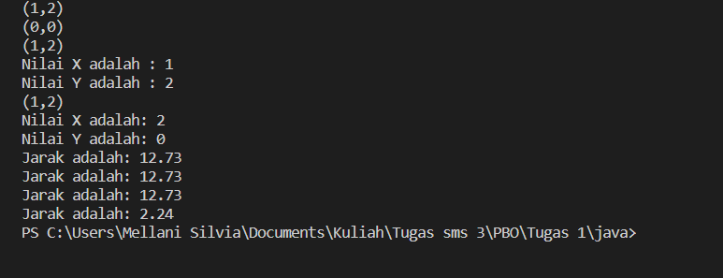

1. Account

* **C++**

1. Circle

1. Date

1. Time

1. Point

1. Account

